COM S 514 Project Idea

Team 5

Bijon Kumar Bose, Zhennan Chen, VijayDeepak Ganappathybharatkumar, Preeti

**1. Summary:**

In this project we aim to develop an application that would be able to collect biometric readings and monitor those readings. If there is any irregularity or abnormality in any of those readings, then the device will send an analysis report automatically to a designated person(Doctor/nurse/CareGiver) to alert them to predict risk of fall or injury or hospitalization etc. and notify them for urgent attention.

**2. Usage:**

The application can be specifically useful in cases where the elderly people stay at home and there is nobody to watch over them all the time, especially during the night. It is even harder for care giver to monitor them all the time. There can be even cases when a person is not able to use a Lifeline button or call someone for help when they suddenly feel unwell or suffer from serious heal breakdown. In such a scenario this application can send a notification to a pre designated person with an analyzed report on biometric readings and possible causes/symptoms of a disease and call for immediate attention. We also aim to preload the application with details about the person on which biometric readings can vary and health conditions of the person.

**3. Challenges:**

The first challenge in the project is to find a suitable device or sensor chips that can read the biometric data of the patient and how to transmit those data to the application with little manual effort. We also need to find correlation between different biometric readings and how we can analyze them to predict a possible cause for health degradation. We also have to optimize the accuracy of the application and sensor devices and make the response time by the application as quick as possible.

**4. Available devices:**

Below are some devices that can detect and monitor biometric readings:

1. **Omron 7 Series Wireless Upper Arm Blood Pressure Monitor with Cuff that fits Standard and Large Arms (BP761) with Bluetooth Smart Connectivity:**

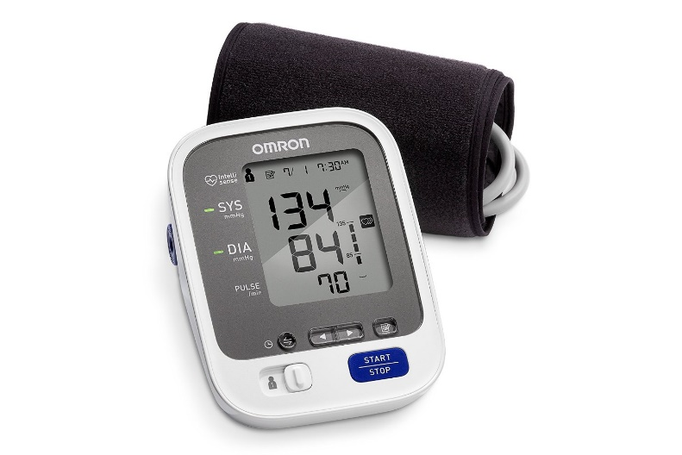

Manage and track up to 120 readings on your blood pressure monitor and unlimited readings on your smartphone with Omron’s free iOS and Android applications (works with select iOS and Android devices, visit OmronHealthcare.com/connect for a complete list of compatible devices)

Comfortable and simple to adjust, the pre-formed ComFit™ Cuff inflates around the entire arm to avoid incorrect cuff positioning ensuring a precise reading and expandable cuff fits standard and large arms. Easy-to-read screen features a backlight, extra large digits and multi-colored indicator lights that show how your reading compares to normal home blood pressure levels.

1. **Activité Steel by Withings :**

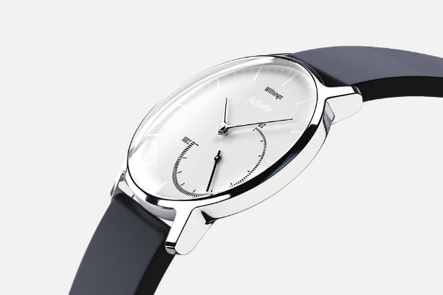

Activity tracking: steps, distance, swim (Water resistant 50ATM), running and calories burned

Sleep monitoring: sleep cycle analysis (light and deep sleep) silent alarm. Automatic synchronisation - Follow your data on your smartphone.

1. **iHealth Sense Wireless Wrist Blood Pressure Monitor for Apple and Android:**

To receive accurate results for the iHealth Sense Blood Pressure Wrist Monitor, connect the device via Bluetooth and open the free iHealth MyVitals app. The iHealth Wireless Blood Pressure Wrist Monitor gives you fast, reliable BP readings you can count on, at home or on the go, right from your smartphone or tablet. The design and cutting-edge technology let you view results, monitor trends, and share your data with your doctor or caregiver right from your touchscreen.

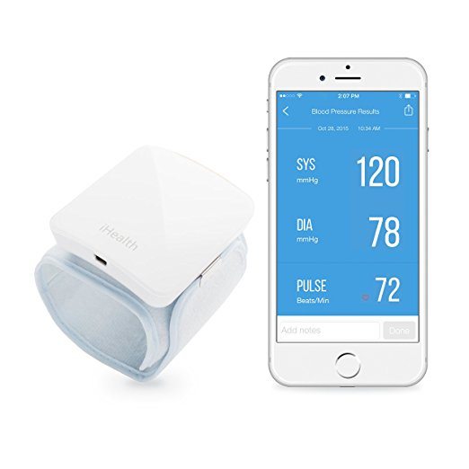

1. **Masimo iSpO2 Pulse Oximeter:**

Oxygen saturation and pulse rate provide critical information. Fingertip pulse oximeters are increasingly being purchased for personal use, but until now, none have been available with Masimo SET Measurethrough Motion and Low Perfusion pulse oximetry, the same technology used on over 100 million patients a year in leading hospitals worldwide. Now, instead of guessing whether your pulse oximeter is providing accurate measurements, rely on Masimo SET technology. From the leader in pulse oximetry, the iSpO2 pulse oximeter provides accurate blood oxygen saturation and pulse rate measurements when other pulse oximeters fail.

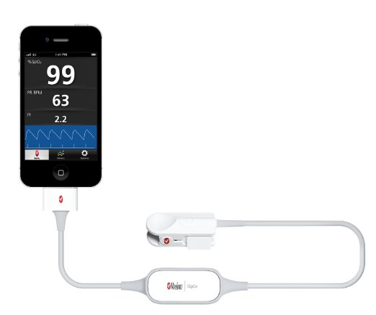

1. **Kardia Band by AliveCor:**

Turns your iOS or Android phone into an ECG device that reports a medical-grade ECG trace and heart rate. From within the app, you can pay to have a cardiologist or cardiac technician help you interpret your ECG data

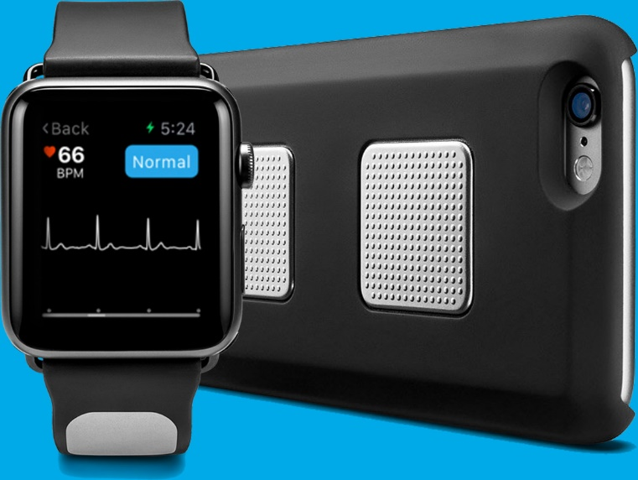

1. **Fitbit Surge:**

Tracks GPS, continuous heart rate, all-day activity stats and sleep.

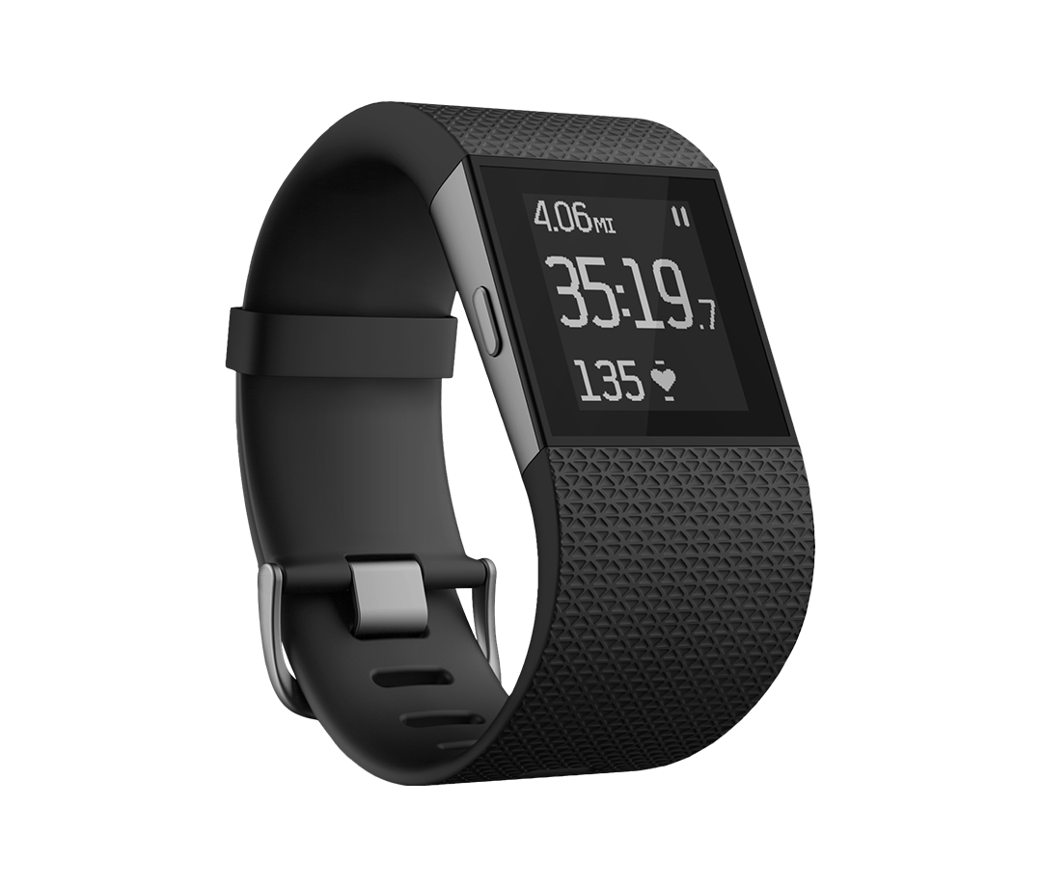

**7. Fitbit Charge:**

Make every beat count with a fitness wristband built with PurePulse® heart rate, multi-sport modes, guided breathing sessions & interchangeable bands.

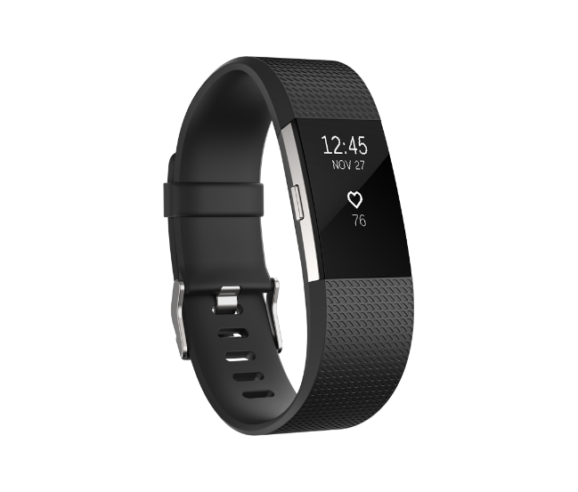



Week 2:

Tasks:

Research:

1. Research Devices:

* Existing devices that read biometric data
* Technology/Method they use to read/store/display/present the data to the user
* Possible ways to capture/read the data from the devices and store in files or stream them into app
* Response time by the devices or time taken to read data from patient

2. Research domain knowledge about biometric readings and possible illness

* Research on how we can utilize the data
* How to co-relate the data to symptoms of illness
* How we can analyze the data from devices
* How can we predict a symptom
* Accuracy of predictions